Web Network Load Balancer
Design Document 1

Version 1.0



Supervisor Name: Tanweer Arshad
Student Name: Faheemullah Memon
Student ID: MC070402736

Revision History

Date (dd/mm/yyyy) | Version | Description | Author
30/11/2012 | 0.1 | Initial draft | Mc070402736
4/12/2012 | 1.0 | Finished and reviewed | Mc070402736

Table of Contents
Revision History 2
1. Introduction 4
2. Overview 4
3. Data Flow Diagrams (DFD) 4
4. Entity Relationship Diagram (ERD) 4
5. Activity Diagram 5
6. Sequence Diagrams (To be developed using Rational Rose) 5
7. Architecture Design Diagram 5

1. Introduction
Every product, software or otherwise, is always developed to solve a particular problem. Or to address a certain limitation that exists with current way of doing things. So in essence, from a cause-and-effect scenario, software is an effect and it can’t be done right without fully understanding the “cause”. Understanding the “cause” is crucial and is covered in the analysis phase.

In analyzing need for a network load balance software application we noted that with ever increasing internet users and limited hardware and network resources it’s inevitable to develop these intelligent systems. In SRS document we also went over the details of such a system, like dynamic vs static CDN’s, system monitoring and health requirement and several abstract models of designing these systems.

This document elaborates and illustrates the abstract ideas introduced in software requirements specification document. Design is another important step of software development life cycle. A good design encapsulates the user requirements and provides an overview of how the system is going to work. Design serves both as an outline of the system and as well as an insight into the software system. Outline helps us maintain the scope of the software and insight gives out enough details for implementation that the work can be carried out.

Design can be done with several tools for different kinds of abstractions. Since this step precedes the implementation, it provides a point to reconcile with all the stakeholders. Using the right kind of modeling tool and abstraction the design can be communicated to the stakeholders.

2. Overview
This software application, network load balancer, is a web based application that will intercept all the web requests for a desired web application and will disperse the requests to the serving server based on context, load/stress volume, and availability. The diagram below illustrates the idea.
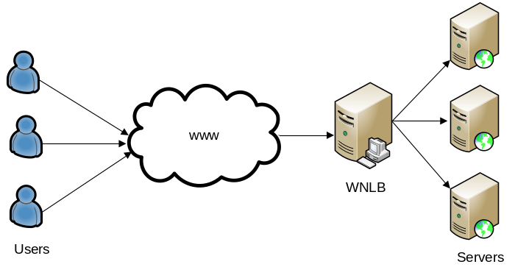

3. Data Flow Diagrams (DFD)
3.1. Contextual Diagram

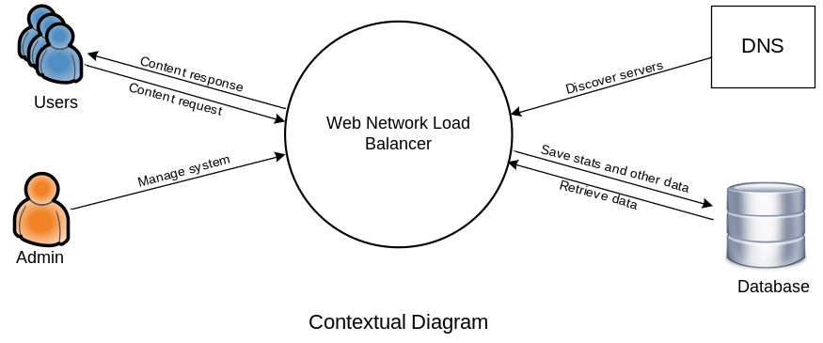

System contextual diagram above shows system’s interaction with external stimuli. There are four main components:

- Users: Users are the beneficiaries of the system. They are routed to the system by DNS or other proxy servers and then system based on certain contextual indicators serves the request from with-in its cluster. This communication is bi-directional.

- Admin: Administrators are the manager of the system. They configure, monitor, and control the system. They keep check on health of the overall system. Their communication can be bi-directional but actual commanding interface is one directional.
- DNS: Domain naming system is used by system for configuration. During configuration wizard or otherwise when adding cluster slaves system tries to auto-discover these system based on SRV records.

- Database: Database is a central and crucial agent of the system. It saves the configuration information, logging and monitoring data, and other indicators. It may also work as communication component between the master and the slave components in the system. Database can be a stand-alone server outside the system, as illustrated, or just an add-on, embedded, component.

3.2. Level-1 Data Flow Diagram

4. Entity Relationship Diagram (ERD)
<Provide Entity Relationship Diagram (ERD) of your system>

5. Activity Diagram
<Provide activity diagram for each major process of the system>

6. Sequence Diagrams (To be developed using Rational Rose)
<Provide Sequence Diagrams for each of the use case to show the task sequence of the system, Provide a sequence diagram for each of the use case provided in use case diagram>

7. Architecture Design Diagram
<Provide a Tiered Architecture of the system>

